Project Name: Deploy Application on Cloud.

## Output:

### Landing Page:

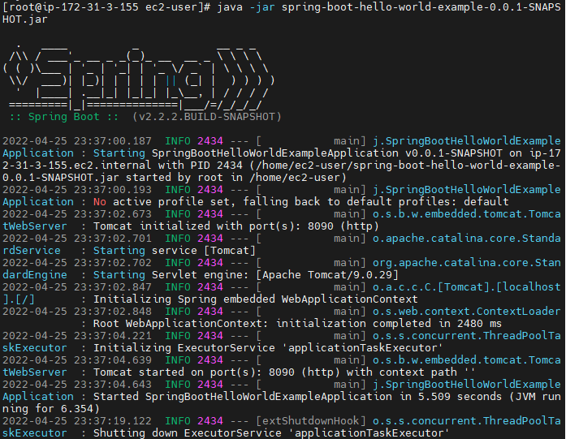

Output on the 8090 Port:

